**STEPS TO USING TEST PROGRAMS**

* Download and install de Psoc Creator (Version 3.3 or higher) of the oficial page: <http://www.cypress.com/products/psoc-creator-integrated-design-environment-ide>.

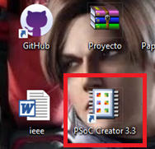

* Download the “Robot_Test” folder from the repository (Availe in: <https://github.com/HenryHdez/Psoc_Modular/tree/master/Robot_Test>).

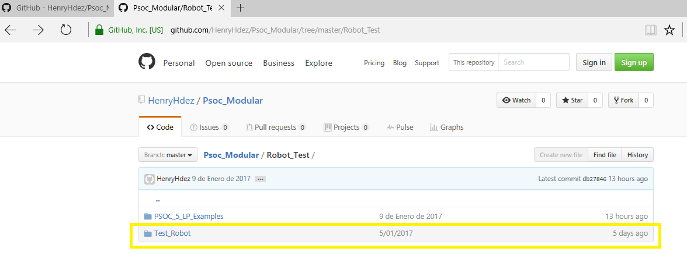

* Now open Project in Psoc Creator program.
  + Open Program



* + Clic in Open Project icon

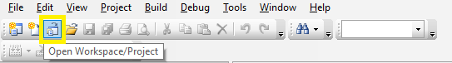

* + Select main Project and open

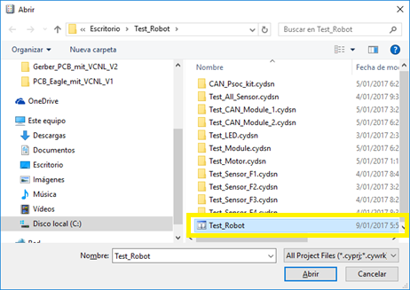

* Now connect the programming cable to the USB terminal of the module

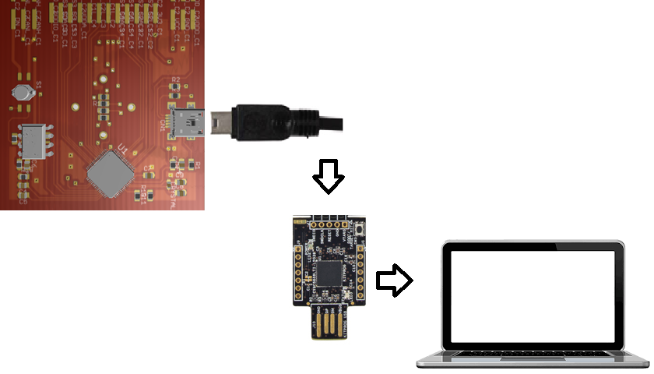

* Select as the main project the application you want to test
  + Right click on the application and select the marked option in the figure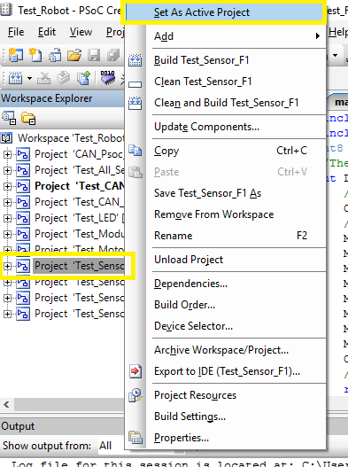
  + And program the module by selecting the button marked

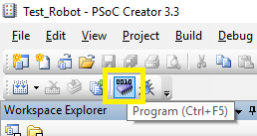

**CONTENT OF THE PROJECT**

|  |  |
| --- | --- |
| **PROGRAM** | **DESCRIPTION** |
| *Test_LED* | This code activates (Frecuency=10Hz) LED lights on each side. |
| *Test_All_Sensor* | The initialization routine is in charge of turning on the LED located next to each sensor, it will do it 5 times if there is communication with it, otherwise it will only do it once.  Once initialize each sensor, if one of them is obstructed turn on the LED that is next to it. |
| *Test_Motor* | This program turns on the motor led once it communicates with it, moves it from right to left and vice versa at intervals of 5 seconds. |
| *Test_Sensor_F1* | All LEDs turn on and off, if there is communication with the face sensor 1. |
| *Test_Sensor_F2* | All LEDs turn on and off, if there is communication with the face sensor 2. |
| *Test_Sensor_F3* | All LEDs turn on and off, if there is communication with the face sensor 3. |
| *Test_Sensor_F4* | All LEDs turn on and off, if there is communication with the face sensor 4. |
| *Test_CAN_Module_1* | Each module sends and receives a data, if the data is accepted, turn on the led of face 2 in each module, otherwise it will not turn on. |
| *Test_CAN_Module_2* |
| *CAN_Psoc_kit* | Show the information on the CAN bus on an LCD display. |

|  |  |
| --- | --- |
| **CONVENTIONS** | |
| **FACE 1** |  |
| **FACE 2** |  |
| **FACE 3** |  |
| **FACE 4** |  |